1.

#include<stdio.h>

int stack[100], choice, n, top, x;

void push(void);

void pop(void);

void display(void);

int main() {

top = -1;

printf("enter the size of stack:\n");

scanf("%d", &n);

printf("the stack operation to be performed");

printf("\n1. push\n2.pop\n3.display\n4.exit\n");

do {

printf("enter the choice:\n");

scanf("%d", &choice);

switch (choice) {

case 1:

push();

break;

case 2:

pop();

break;

case 3:

display();

break;

case 4:

printf("exit point");

break;

default:

printf("\n enter the valide choice\n");

}

} while (choice != 4);

return 0;

}

void push() {

if (top == n - 1) {

printf("\nstack is overflow");

} else {

printf("enter the value to be pushed:");

scanf("%d", &x);

top++;

stack[top] = x;

}

}

void pop() {

if (top == -1) {

printf("stack is underflow");

} else {

printf("the poped element is : %d\n", stack[top]);

top--;

}

}

void display() {

int i;

if (top >= 0) {

printf("the elements in the stack:\n");

for (i = top; i >= 0; i--)

printf("%d\n", stack[i]);

} else {

printf("the stack is empty \n ");

}

}

2.#include<stdio.h>

#include<ctype.h>

char stack[100];

int top=-1;

void push(char x)

{

stack[++top]=x;

}

char pop()

{

if(top==-1)

return -1;

else

return stack[top--];}

int priority(char x)

{

if (x == '(')

return 0;

if (x == '+' || x == '-')

return 1;

if (x == '\*' || x == '/')

return 2;

return 0;

}

int main()

{

char exp[100];

char \*e,x;

printf("enter the expression:");

scanf("%s", exp);

e=exp;

while (\*e != '\0')

{

if (isalnum(\*e))

printf("%c", \*e);

else if (\*e == '(')

push(\*e);

else if (\*e == ')')

{

while ((x = pop()) != '(')

printf("%c", x);

}

else

{

while (priority(stack[top]) >= priority(\*e))

printf("%c", pop());

push(\*e);

}

e++;

}

while (top != -1)

{

printf("%c", pop());

}

return 0;

}

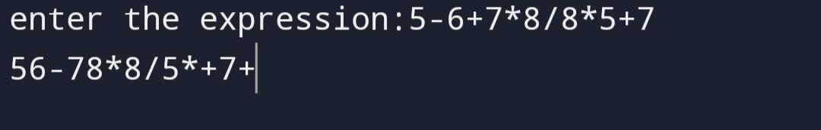

3.

#include<stdio.h>

#include<ctype.h>

char stack[20];

int top=-1;

void push(char x)

{

stack[++top]=x;

}

int pop()

{

return stack[top--];

}

int main()

{

char exp[20];

char \*e;

int n1,n2,n3,num;

printf("enter the expression::");

scanf("%s",exp);

e=exp;

while(\*e!='\0')

{

if(isdigit(\*e))

{

num=\*e-48;

push(num);

}

else

{

n1=pop();

n2=pop();

switch(\*e)

{

case '+':

{

n3=n1+n2;

break;

}

case '-':

{

n3=n1-n2;

break;

}

case '\*':

{

n3=n1\*n2;

break;

}

case '/':

{

n3=n2/n1;

break;

}

}

push(n3);

}

e++;

}

printf("\nthe result of the expression %s=%d\n", exp , pop());

return 0;

}

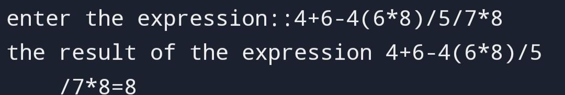

4.

#include<stdio.h>

void toh(int n, char a, char c, char b)

{

if(n==1)

{

printf("\n move disk 1 from rod %c to rod %c ", a,b);

return;

}

toh(n-1, 'a', 'c', 'b'); // move n-1 disks from 'a' to 'c', using 'b' as auxiliary peg

printf("\n move disk %d from rod %c to rod %c", n,a,b);

toh(n-1, 'c', 'b', 'a'); // move n-1 disks from 'c' to 'b', using 'a' as auxiliary peg

}

int main()

{

int n=4;

toh(n,'a','b','c');

return 0;

}

